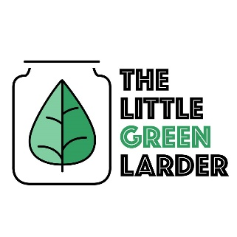

The Little Green Larder

Cajun chick pea burger with wedges

Garlic  
Onion  
Carrot  
Courgette  
Chickpeas  
Cajun spices  
Potato   
Paprika spice mix

- Soak chickpeas for 4 – 8hours (we just leave them overnight), rinse then place in a pot of water. Bring to boil then simmer for 1 hour. Drain and set aside

- Cut potatoes into wedges and place on a baking tray. Lightly drizzle over some oil and sprinkle on the wedge spice mix. Cook at 200/ gas mark 6 for 15 – 20 mins

- Grate the carrots and courgette, squeeze excess water out with a towel or napkin

- Blend/ mash chickpeas until they are coarsely mashed, but not to a paste.

- Chop the onion and 2 – 4 garlic cloves, fry with the Cajun spice mix for 2- 4 mins

- Combine all of the ingredients in a bowl, add salt and pepper to taste. Form into burgers and fry in oil for 5 mins each side

- Serve and enjoy

Serves 2